**Acknowledgement**

I thank principal ma’am and our supervisor for giving me permission to learn in detail about my subject matter. My sincere gratitude goes towards our Computer Science Teacher, Mrs. Santhi Krishnan for giving me the opportunity to finish this project, and for providing her support throughout in the best way possible. Without all of you, this project may never have been possible.

**Index**

|  |  |  |
| --- | --- | --- |
| **Serial**  **Number** | **Contents** | **Page Number** |
| 1 | Certificate | 2 |
| 2 | Acknowledgement | 3 |
| 3 | Index | 4 |
| 4 | Overview | 5 |
| 5 | Software and Hardware Requirements | 6 |
| 6 | Functions, Modules and Packages Used | 7 |
| 7 | Source Code | 8 |
| 8 | Output | 29 |
| 9 | Conclusion | 57 |
| 10 | Bibliography | 58 |

**Overview of the Project**

The aim of this project is to come up with software that aggregates enormous amounts of aviation-related data into an interface that aids travellers in navigating the hugely complex world of flight bookings.

The Program first checks whether the database has already been configured on the system. If it hasn’t been, then it creates the database, extracts the data from the datasets (see below), and uploads them into sql tables. If the data was already available on sql, then the above step is skipped and the user-oriented part of the program starts up.

Users are greeted by a banner followed by 5 options. Choosing the first option, *Explore all Routes*, allows users to grasp the sheer scale of the data available in this program. We can enter the country name, the city name, and the IATA Code of the airport (or just one of these) and the program can fish out every single flight operated out of the place. If a user simply wishes to see which flights go out of Turkmenistan, they may just put the country name and leave the rest of the criteria blank. If a user would like to find flights out of their home city, then they can leave the rest of the criteria blank.

The second option, *Find your flight*, allows you to find all flights between two airports. The users must enter the cities in which the two airports are situated and will be provided with the codes of all the airports in these towns. After specifying the code, the users will now be able to view all the routes flown by different airlines between the two airports. If there are no direct flights between the two airports, the program will find intermediate airports that are connected to both the source and destination airports and display the routes flown by the airport to that end.

The Third option, *Access Saved Routes*, allows the user to save the flights displayed in the second option onto a csv file. The user can add a route, delete a route, and see all the saved routes. It will all be based on flight numbers that will be displayed when using the second option.

The fourth option, *Find out how to work the program*, provides the user with information on how to use the program and how it works.

Lastly, the user can press 5 to exit the program.

**The project is founded on 3 datasets** obtained from reputable sources on the Internet. All the airport and airline codes are based on IATA regulations.

The first dataset, “Routes.csv”, contains a set of 67,663 flight routes flown across the globe, all the way from regional flights to intercontinental ones. It includes the airline code of the company flying the route, the source and destination codes and ids, as well as other miscellaneous information.

The second dataset, “Airlines.csv” contains a list of 947 airline names followed by their codes.

The last dataset is “Globalairportdatabase.txt” that contains 9300 entries on the airports of the world. Nearly every airport and aerodrome in every part of the world is covered here, with their ICAO Codes, IATA Codes, Airport Names, City, Country, and Coordinates all made available.

**Requirements: Software and Hardware**

This program was built in the Spyder IDE on Python 3.8. Therefore, Python of versions 3.8 or later must be used along with any IDE of your choice.

Additionally, SQL and the MySQL.Connector module must be downloaded and added to the path before the execution of the programme. This program also uses the csv module, but as that usually is automatically available on most IDEs, it shouldn’t cause much trouble.

**Modules, Functions, and Packages:**

* CSV Module

To access the files “routes.csv” and “airlines.csv”, so as to populate an SQL Database “Flightaggregator3”. It was also used save, access, and view routes in the “Savedroutes.csv” file

* Mysql.connector Module

To create and access the SQL database “Flightaggregator3” so as to combine the data from various sources and integrate them into one interface. The whole program hinges on accessing data from sql tables in the Database.

* Csvtosql() Module:

This user-defined function first checks whether the database exists. If the database and its data had already been configured on the computer at an earlier point, it skips the rest of the function as well as the next two functions and moves directly on to the Asksql function.   
If the database doesn’t exist it is first created. Then, it accesses the csv file “routes.csv”. It creates a table for each letter of the code for the *source_airport* column for easy access later on. Then, it adds all the records in the appropriate tables on the basis of their first letter of the *source_airport*.

* Csvtosql2() Module

This user-defined function accesses the csv file “airlines.csv” and then adds a table “airlines” to store all the data from the csv file.

* Texttosql() Module:

This user-defined function accesses the text file “GlobalAirportDatabase.txt” to store all of its data in a table “Airportdata”.

* Asksql() Module:

Once all the data has been configured, this function is put into action. This is where the majority of the user-oriented functionality lies.

**Source Code**

# -*- coding: utf-8 -*-

"""

Created on Tue Aug 27 23:42:34 2024

@author: Navneet

"""

"""Travel Aggregator"""

#%%

import csv

import mysql.connector as sqlconnect

print("__________________________________________________________")

print("| |")

print("| |")

print("| ___ __ __ __ |")

print("| | |__| |__| |_ _| |_ | |")

print("| | |\ | | | | | | |")

print("| | | \ | | |_| |__ |___ |")

print("| |")

print("| __ ___ ___ ___ __ ___ __ ___ ___ ___ |")

print("| | | | | |__| | | | | | | | |__| |")

print("| |__| | __ | __ |\ |_ | __ |__| | | | |\ |")

print("| | | |__| |__| | \ |__ |__| | | | |__| | \ |")

print("| |")

print("| Press Enter to start |")

print("_________________________________________________________|")

a = input()

print()

"""Function to convert CSV file 'routes.csv' to a SQL file"""

def csvtosql():

try:

sqlconnext = sqlconnect.connect(host = "localhost", user = "root", password = "Lacnor", database = "flightaggregator2")

except:

pathcsv1 = "C:/Users/USER/Desktop/Programs/Flight Aggregator/routes.csv"#input("Enter Path of routes.csv: ")

pathcsv2 = "C:/Users/USER/Desktop/Programs/Flight Aggregator/Airlines.csv"#input("Enter Path of airlines.csv: ")

pathtxt = "C:/Users/USER/Desktop/Programs/Flight Aggregator/GlobalAirportDatabase.txt"#input("Enter Path of GlobalairportDatabase.txt")

connext = sqlconnect.connect(host = "localhost", user = "root", password = "Lacnor")

cursor= connext.cursor()

command = "create database flightaggregator3;"

cursor.execute(command)

connext.commit()

connext.close()

sqlconnext = sqlconnect.connect(host = "localhost", user = "root", password = "Lacnor", database = "flightaggregator3")

airlinelis = ["123_","456_","789_","A","B","C","D","E","F","G","H","I","J"

,"K","L","M","N","O","P","Q","R","S","T","U","V","W","X","Y","Z"]

cursor = sqlconnext.cursor()

for i in airlinelis:

creator = "create table "+i+"(airlinecode varchar(100),airline_id varchar(100),source_airport varchar(100),sourceairportid varchar(100),destination_airport varchar(100), destinationairport_id varchar(100),code_share varchar(100), stops varchar(100),equipment varchar(100));"

cursor.execute(creator)

sqlconnext.commit()

for j in airlinelis:

with open(pathcsv1,"r") as f1:

reader1 = csv.reader(f1)

for k in reader1:

if k[2][0] in j:

tup1 = tuple(k)

command1 = "insert into "+str(j)+" values"+str(tup1)+";"

cursor.execute(command1)

sqlconnext.commit()

sqlconnext.close()

print("Uploaded routes.csv into sql!")

csvtosql2()

txttosql()

def csvtosql2():

sqlconnext = sqlconnect.connect(host = "localhost", user = "root", password = "Lacnor", database = "flightaggregator2")

if sqlconnext.is_connected:

print("Database Connected")

cursor= sqlconnext.cursor()

command = "create table airlines(Code Varchar(4),Name Varchar(100));"

cursor.execute(command)

sqlconnext.commit()

with open(pathcsv2,"r") as f:

a = csv.reader(f)

for i in a:

command = "insert into airlines values('"+str(i[0])+"','"+str(i[1])+"');"

try:

cursor.execute(command)

sqlconnext.commit()

except:

pass

sqlconnext.close()

print("Uplaoded airlines.csv into sql")

"""Function to convert txt file 'GlobalAirportDatabase.txt' to a SQL file"""

def txttosql():

sqlconnext = sqlconnect.connect(host = "localhost", user = "root", password = "Lacnor", database = "flightaggregator2")

txt = open(pathtxt)

regulator = 0

cursor = sqlconnext.cursor()

command = "create table airportdata (ICAOcode varchar(100),IATAcode varchar(100), AirportName varchar(100), City varchar(100), Country varchar(100))"

cursor.execute(command)

sqlconnext.commit()

print("Done")

while True:

line = txt.readline()

tupline = tuple(line.split(":"))

try:

tup = (tupline[0],tupline[1],tupline[2],tupline[3],tupline[4])

except IndexError:

print("SQL file is ready!")

break

print(tup)

command = "insert into airportdata values"+str(tup)+";"

print(command)

cursor.execute(command)

sqlconnext.commit()

txt.close()

sqlconnext.close()

print("Uploaded Global Airport database into sql")

csvtosql()

def asksql():

counter = 0

counters = 0

sqlconnext = sqlconnect.connect(host = "localhost", user = "root", password = "Lacnor", database = "flightaggregator2")

lis = []

lisf = []

liss = []

while True:

cursor = sqlconnext.cursor()

print()

print("Enter 1 to Explore all routes")

print("Enter 2 to Find your flight")

print("Enter 3 to Access Saved Routes")

print("Enter 4 to Find out how to work the program")

print("Enter 5 to exit")

print()

choice = input("Enter your choice: ")

if choice == "1":

lis = []

print()

print("Enter at least one of the following to view all air routes through them")

country = input("Name of the country: ")

depcity = input("City of departure: ")

code = input("Enter the IATA code of arriving airport: ")

print()

choice1lis = [[country,"country"],[depcity,"city"],[code,"IATAcode"]]

counter = 0

for i in choice1lis:

if i[0]:

counter = counter + 1

if counter == 1:

command = 'select * from airportdata where '+str(i[1])+' = "'+str(i[0])+'"'

if counter > 1:

command = command + ' and '+str(i[1])+' = '+'"'+str(i[0])+'"'

command = command + ";"

cursor.execute(command)

data = cursor.fetchall()

cursor = sqlconnext.cursor()

counter2 = 0

routesdata = []

for i in data:

switchdata = i[1]

command = 'select * from '+str(switchdata[0])+' where source_airport = "'+str(switchdata)+'";'

cursor.execute(command)

data2 = cursor.fetchall()

for j in data2:

counter2 = counter2 + 1

routesdata.append([counter2,j[0],j[2],j[4]])

print("No., Airline code, Code of depart,Name of airport,City,Country,Code of arriv, Name, City, Country")

counter3 = 0

for i in routesdata:

cursor = sqlconnext.cursor()

command = 'select IATAcode,Airportname,City,Country from airportdata where IATAcode = "'+str(i[3])+'";'

cursor.execute(command)

arriv = cursor.fetchall()

if not arriv:

continue

cursor = sqlconnext.cursor()

command = 'select IATAcode,Airportname,City,Country from airportdata where IATAcode = "'+str(i[2])+'";'

cursor.execute(command)

depart = cursor.fetchall()

counter3 = counter3 + 1

print(counter3,i[1],"From",depart[0][0],depart[0][1],depart[0][2],depart[0][3],"To",arriv[0][0],arriv[0][1],arriv[0][2],arriv[0][3])

elif choice == "2":

departing = input("Enter City of Departure:")

cursor = sqlconnext.cursor()

command = "select * from airportdata where city = '"+departing+"';"

cursor.execute(command)

a = cursor.fetchall()

print()

if len(a) >= 1:

print("Code : Name of the Airport : City")

for i in a:

print(i[1]," : ",i[2]," : ",i[3])

departurecode = input("Enter the Code of the airport of Departure: ")

else:

print("The name of this City is invalid. Try again")

departurecode = None

print()

arrival = input("Enter city of Arrival: ")

command = "select * from airportdata where city = '"+arrival+"';"

cursor.execute(command)

a = cursor.fetchall()

print()

if len(a) >= 1:

print("Code : Name of the Airport : City")

for i in a:

print(i[1]," : ",i[2]," : ",i[3])

arrivalcode = input("Enter the Code of the airport of Arrival: ")

else:

print("The name of this city is invalid. Try Again")

arrivalcode = None

if departurecode is not None and arrivalcode is not None:

startingletter = departurecode[0]

command = "select * from "+startingletter+" where destination_airport ='"+arrivalcode+"' and source_airport = '"+departurecode+"';"

print()

cursor.execute(command)

a = cursor.fetchall()

if len(a) == 0:

lis = []

print("There are no direct flights. But these connecting flights are available!")

print()

command = "select * from "+startingletter+" where source_airport ='"+departurecode+"';"

cursor.execute(command)

a = cursor.fetchall()

print("Airline : Source airport : : Destination Airport")

for i in a:

command = "select * from "+i[4][0]+" where destination_airport ='"+arrivalcode+"' and source_airport = '"+i[4]+"';"

cursor.execute(command)

b = cursor.fetchall()

if len(b) == 0:

pass

else:

counters = counters + 1

command = "select * from airlines where code = '"+i[0]+"';"

cursor.execute(command)

c = cursor.fetchall()

print(counters, end = " ")

try:

airf = c[0][1]

print(airf, end = " : ")

except:

airf = "NA"

print(airf, end = " : ")

command = "select * from airportdata where IATAcode = '"+i[2]+"';"

cursor.execute(command)

d = cursor.fetchall()

try:

birf = d[0][2]

print(birf, end = " : ")

except:

birf = "NA"

print(birf, end = " : ")

command = "select * from airportdata where IATAcode = '"+i[4]+"';"

cursor.execute(command)

e = cursor.fetchall()

try:

cirf = e[0][2]

print(cirf, end = " : ")

except:

cirf = "NA"

print(cirf, end = " : ")

print()

lisf.append([counters,airf,birf,cirf])

print("Followed by: ")

command = "select * from airlines where code = '"+b[0][0]+"';"

cursor.execute(command)

c = cursor.fetchall()

print(counters, end = " ")

try:

airs = c[0][1]

print(airs, end = " : ")

except:

airs = "NA"

print(airs, end = " : ")

command = "select * from airportdata where IATAcode = '"+b[0][2]+"';"

cursor.execute(command)

d = cursor.fetchall()

try:

birs = d[0][2]

print(birs, end = " : ")

except:

birs = "NA"

print(birs, end = " : ")

command = "select * from airportdata where IATAcode = '"+b[0][4]+"';"

cursor.execute(command)

e = cursor.fetchall()

try:

cirs = e[0][2]

print(cirs, end = " : ")

except:

cirs = "NA"

print(cirs, end = " : ")

print()

print()

liss.append([counters,airs,birs,cirs])

else:

liss = []

lisf = []

print("Airline : Source airport : : Destination Airport")

for i in a:

counters = counters + 1

command = "select * from airlines where code ='"+i[0]+"';"

cursor.execute(command)

c = cursor.fetchall()

print(counters, end = " ")

try:

air = c[0][1]

print(air, end = " : ")

except:

air = "NA"

print(air, end = " : ")

command = "select * from airportdata where IATAcode = '"+i[2]+"';"

cursor.execute(command)

d = cursor.fetchall()

try:

bir = d[0][2]

print(bir, end = " : ")

except:

bir = "NA"

print(bir, end = " : ")

command = "select * from airportdata where IATAcode = '"+i[4]+"';"

cursor.execute(command)

e = cursor.fetchall()

try:

cir = e[0][2]

print(cir, end = " : ")

except:

cir = "NA"

print(cir, end = " : ")

print()

lis.append([counter,air,bir,cir])

elif choice == "3":

while True:

print()

print("Enter 1 to Add a route")

print("Enter 2 to delete a route")

print("Enter 3 to see all saved routes")

print("Enter 4 to go back")

print()

choices = input("Enter your choice: ")

if choices == "1":

if liss == [] and lisf == []:

if len(lis) == 0:

print("You can only Save Routes after looking up specific flights")

else:

number = int(input("Enter the Route number of the flight to be saved: "))

with open("Savedroutes.csv","r") as f:

a = csv.reader(f)

count = len(list(a))

with open("Savedroutes.csv","a+",newline = "") as f:

a = csv.writer(f)

adder = [count+1,lis[number-1][1],lis[number-1][2],lis[number-1][3]]

a.writerow(adder)

elif lis == []:

if len(lisf) == 0 or len(liss) == 0:

print("You can only save routes after looking up specific flights")

else:

number = int(input("Enter the Route number of the flight to be saved: "))

with open("Savedroutes.csv","r") as f:

a = csv.reader(f)

count = len(list(a))

with open("Savedroutes.csv","a+",newline = "") as f:

a = csv.writer(f)

adder = [count+1,lisf[number-1][1],lisf[number-1][2],lisf[number-1][3],"|",liss[number-1][1],liss[number-1][2],liss[number-1][3]]

a.writerow(adder)

liss = []

lisf = []

lis = []

elif choices == "2":

with open("Savedroutes.csv","r") as f:

a = csv.reader(f)

lisa = list(a)

number = int(input("Enter the Number of the route to be deleted."))

with open("Savedroutes.csv","w", newline = "") as f:

b = csv.writer(f)

for i in lisa:

if int(i[0]) != number:

b.writerow(i)

liss = []

lisf = []

lis = []

elif choices == "3":

with open("Savedroutes.csv","r") as f:

a = csv.reader(f)

for i in a:

print(i)

liss = []

lisf = []

lis = []

elif choices == "4":

break

liss = []

lisf = []

lis = []

else:

print("Enter a valid choice!")

elif choice == "4":

print("Travel Aggregator")

print()

print("""

Users can make use of this software to optimise their long-distance travel.

We will start with a Welcome screen where the following options would be displayed:

1. Explore Routes

2. Find your flight

3. Saved Routes

4. Learn more about the software

Explore your routes enables you to search up all flight options availble in different

countries and cities. It allows one to get a sense of the scale of the

available data and spot patterns.

You can enter your destinaiton and your starting point and the software will

find list out all available flights by different airlines. If there are no

direct flights between the two destinations, then the code finds out which

airports the airport of departure does have flights to and if any of these

airports have routes connecting them with the final destination. As of now

the code can only find routes with one connecting flight.

Saved Routes allows you to store and view the routes you found. There are

seperate options to view, add, and delete routes.

This software is the amalgamation of 3 large datasets. The first one was a

csv file that contains a list of all the routes between different airports.

It also holds the the various airport codes, airline codes, and other

miscellaneous data.

The second dataset is a textfile that contains the IATA airport codes,and

data on the airport, city, and country names.

The last dataset is a csv file that contains IATA airline codes along with

the airline names.

This program accesses these files and uplaodes their data onto sql, from

where they are linked up to provide all the information we need.

""")

elif choice == "5":

break

else:

print("Enter a valid opton!")

asksql()

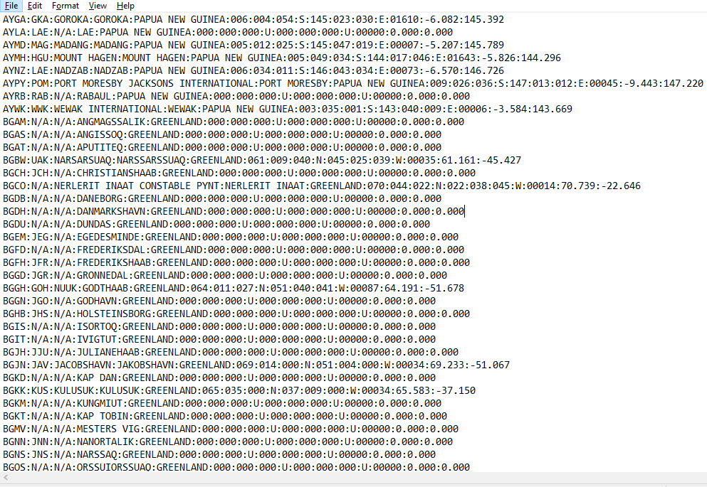

**Output**

**1. Uploading the csv and text files to SQL and finding all the routes out of a country:**

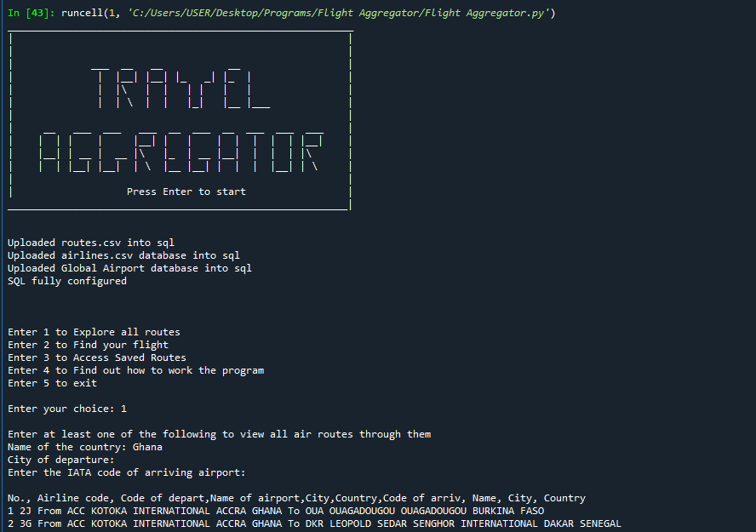

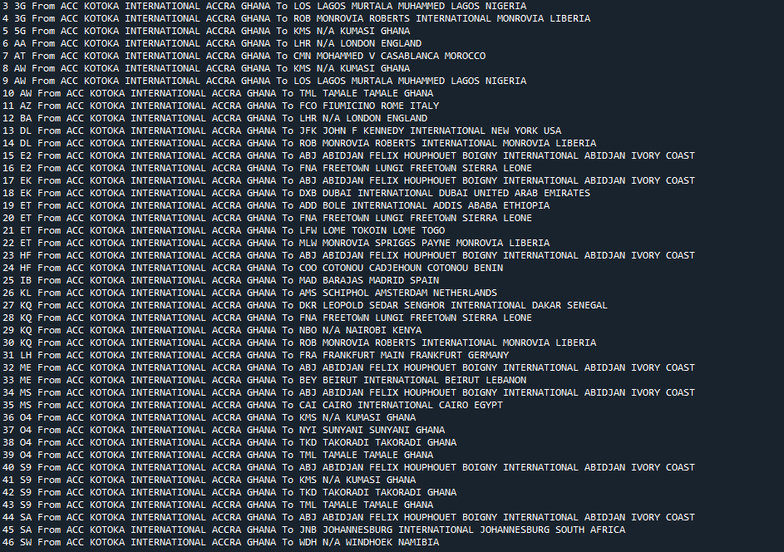

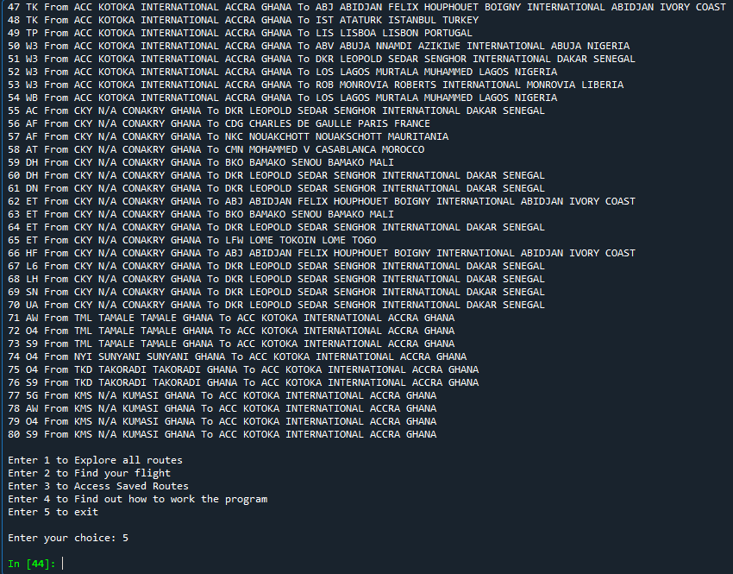

**2. Finding the routes out of a Country plus city**

__________________________________________________________

| |

| |

| ___ __ __ __ |

| | |__| |__| |_ _| |_ | |

| | |\ | | | | | | |

| | | \ | | |_| |__ |___ |

| |

| __ ___ ___ ___ __ ___ __ ___ ___ ___ |

| | | | | |__| | | | | | | | |__| |

| |__| | __ | __ |\ |_ | __ |__| | | | |\ |

| | | |__| |__| | \ |__ |__| | | | |__| | \ |

| |

| Press Enter to start |

_________________________________________________________|

Enter 1 to Explore all routes

Enter 2 to Find your flight

Enter 3 to Access Saved Routes

Enter 4 to Find out how to work the program

Enter 5 to exit

Enter your choice: 1

Enter at least one of the following to view all air routes through them

Name of the country: Chile

City of departure: Santiago

Enter the IATA code of arriving airport:

No., Airline code, Code of depart,Name of airport,City,Country,Code of arriv, Name, City, Country

1 5P From SCL ARTURO MERINO BENITEZ INTERNATIONAL SANTIAGO CHILE To ANF CERRO MORENO INTERNATIONAL ANTOFAGASTA CHILE

2 5Q From SCL ARTURO MERINO BENITEZ INTERNATIONAL SANTIAGO CHILE To MVD ANGEL S ADAMI MONTEVIDEO URUGUAY

3 AA From SCL ARTURO MERINO BENITEZ INTERNATIONAL SANTIAGO CHILE To DFW DALLAS FORT WORTH INTERNATIONAL DALLAS-FORT WORTH USA

4 AA From SCL ARTURO MERINO BENITEZ INTERNATIONAL SANTIAGO CHILE To JFK JOHN F KENNEDY INTERNATIONAL NEW YORK USA

5 AA From SCL ARTURO MERINO BENITEZ INTERNATIONAL SANTIAGO CHILE To LIM JORGE CHAVEZ INTERNATIONAL LIMA PERU

6 AA From SCL ARTURO MERINO BENITEZ INTERNATIONAL SANTIAGO CHILE To MIA MIAMI INTERNATIONAL MIAMI USA

7 AA From SCL ARTURO MERINO BENITEZ INTERNATIONAL SANTIAGO CHILE To PMC EL TEPUAL INTERNATIONAL PUERTO MONTT CHILE

8 AC From SCL ARTURO MERINO BENITEZ INTERNATIONAL SANTIAGO CHILE To EZE N/A BUENOS AIRES ARGENTINA

9 AC From SCL ARTURO MERINO BENITEZ INTERNATIONAL SANTIAGO CHILE To YYZ LESTER B PEARSON INTERNATIONAL TORONTO CANADA

10 AF From SCL ARTURO MERINO BENITEZ INTERNATIONAL SANTIAGO CHILE To CDG CHARLES DE GAULLE PARIS FRANCE

11 AM From SCL ARTURO MERINO BENITEZ INTERNATIONAL SANTIAGO CHILE To MEX LICENCIADO BENITO JUAREZ INTERNATIONAL MEXICO CITY MEXICO

12 AR From SCL ARTURO MERINO BENITEZ INTERNATIONAL SANTIAGO CHILE To AEP AEROPARQUE JORGE NEWBERY BUENOS AIRES ARGENTINA

13 AR From SCL ARTURO MERINO BENITEZ INTERNATIONAL SANTIAGO CHILE To EZE N/A BUENOS AIRES ARGENTINA

14 AV From SCL ARTURO MERINO BENITEZ INTERNATIONAL SANTIAGO CHILE To ANF CERRO MORENO INTERNATIONAL ANTOFAGASTA CHILE

15 AV From SCL ARTURO MERINO BENITEZ INTERNATIONAL SANTIAGO CHILE To BOG ELDORADO INTERNATIONAL BOGOTA COLOMBIA

16 AV From SCL ARTURO MERINO BENITEZ INTERNATIONAL SANTIAGO CHILE To LIM JORGE CHAVEZ INTERNATIONAL LIMA PERU

17 AZ From SCL ARTURO MERINO BENITEZ INTERNATIONAL SANTIAGO CHILE To CDG CHARLES DE GAULLE PARIS FRANCE

18 CM From SCL ARTURO MERINO BENITEZ INTERNATIONAL SANTIAGO CHILE To PTY TOCUMEN INTERNATIONAL PANAMA CITY PANAMA

19 DL From SCL ARTURO MERINO BENITEZ INTERNATIONAL SANTIAGO CHILE To ATL THE WILLIAM B HARTSFIELD ATLANTA INTERNATIONAL ATLANTA USA

20 H2 From SCL ARTURO MERINO BENITEZ INTERNATIONAL SANTIAGO CHILE To ANF CERRO MORENO INTERNATIONAL ANTOFAGASTA CHILE

21 H2 From SCL ARTURO MERINO BENITEZ INTERNATIONAL SANTIAGO CHILE To CCP CARRIEL SUR INTERNATIONAL CONCEPCION CHILE

22 H2 From SCL ARTURO MERINO BENITEZ INTERNATIONAL SANTIAGO CHILE To CJC EL LOA CALAMA CHILE

23 H2 From SCL ARTURO MERINO BENITEZ INTERNATIONAL SANTIAGO CHILE To CPO CHAMONATE COPIAPO CHILE

24 H2 From SCL ARTURO MERINO BENITEZ INTERNATIONAL SANTIAGO CHILE To EZE N/A BUENOS AIRES ARGENTINA

25 H2 From SCL ARTURO MERINO BENITEZ INTERNATIONAL SANTIAGO CHILE To GRU GUARULHOS SAO PAULO BRAZIL

26 H2 From SCL ARTURO MERINO BENITEZ INTERNATIONAL SANTIAGO CHILE To IQQ DIEGO ARACENA INTERNATIONAL IQUIQUE CHILE

27 H2 From SCL ARTURO MERINO BENITEZ INTERNATIONAL SANTIAGO CHILE To LSC LA FLORIDA LA SERENA CHILE

28 H2 From SCL ARTURO MERINO BENITEZ INTERNATIONAL SANTIAGO CHILE To PMC EL TEPUAL INTERNATIONAL PUERTO MONTT CHILE

29 H2 From SCL ARTURO MERINO BENITEZ INTERNATIONAL SANTIAGO CHILE To ZCO MAQUEHUE TEMUCO CHILE

30 IB From SCL ARTURO MERINO BENITEZ INTERNATIONAL SANTIAGO CHILE To MAD BARAJAS MADRID SPAIN

31 JJ From SCL ARTURO MERINO BENITEZ INTERNATIONAL SANTIAGO CHILE To GIG GALEAO ANTONIO CARLOS JOBIM RIO DE JANEIRO BRAZIL

32 JJ From SCL ARTURO MERINO BENITEZ INTERNATIONAL SANTIAGO CHILE To GRU GUARULHOS SAO PAULO BRAZIL

33 JJ From SCL ARTURO MERINO BENITEZ INTERNATIONAL SANTIAGO CHILE To IQQ DIEGO ARACENA INTERNATIONAL IQUIQUE CHILE

34 JJ From SCL ARTURO MERINO BENITEZ INTERNATIONAL SANTIAGO CHILE To LIM JORGE CHAVEZ INTERNATIONAL LIMA PERU

35 JL From SCL ARTURO MERINO BENITEZ INTERNATIONAL SANTIAGO CHILE To LIM JORGE CHAVEZ INTERNATIONAL LIMA PERU

36 KE From SCL ARTURO MERINO BENITEZ INTERNATIONAL SANTIAGO CHILE To ATL THE WILLIAM B HARTSFIELD ATLANTA INTERNATIONAL ATLANTA USA

37 KE From SCL ARTURO MERINO BENITEZ INTERNATIONAL SANTIAGO CHILE To LIM JORGE CHAVEZ INTERNATIONAL LIMA PERU

38 KL From SCL ARTURO MERINO BENITEZ INTERNATIONAL SANTIAGO CHILE To EZE N/A BUENOS AIRES ARGENTINA

39 LA From SCL ARTURO MERINO BENITEZ INTERNATIONAL SANTIAGO CHILE To AEP AEROPARQUE JORGE NEWBERY BUENOS AIRES ARGENTINA

40 LA From SCL ARTURO MERINO BENITEZ INTERNATIONAL SANTIAGO CHILE To AKL AUCKLAND INTERNATIONAL AUCKLAND NEW ZEALAND

41 LA From SCL ARTURO MERINO BENITEZ INTERNATIONAL SANTIAGO CHILE To ANF CERRO MORENO INTERNATIONAL ANTOFAGASTA CHILE

42 LA From SCL ARTURO MERINO BENITEZ INTERNATIONAL SANTIAGO CHILE To ARI CHACALLUTA ARICA CHILE

43 LA From SCL ARTURO MERINO BENITEZ INTERNATIONAL SANTIAGO CHILE To ASU SILVIO PETTIROSSI INTERNATIONAL ASUNCION PARAGUAY

44 LA From SCL ARTURO MERINO BENITEZ INTERNATIONAL SANTIAGO CHILE To BBA BALMACEDA BALMACEDA CHILE

45 LA From SCL ARTURO MERINO BENITEZ INTERNATIONAL SANTIAGO CHILE To BOG ELDORADO INTERNATIONAL BOGOTA COLOMBIA

46 LA From SCL ARTURO MERINO BENITEZ INTERNATIONAL SANTIAGO CHILE To CCP CARRIEL SUR INTERNATIONAL CONCEPCION CHILE

47 LA From SCL ARTURO MERINO BENITEZ INTERNATIONAL SANTIAGO CHILE To CCS SIMON BOLIVAR INTERNATIONAL CARACAS VENEZUELA

48 LA From SCL ARTURO MERINO BENITEZ INTERNATIONAL SANTIAGO CHILE To CJC EL LOA CALAMA CHILE

49 LA From SCL ARTURO MERINO BENITEZ INTERNATIONAL SANTIAGO CHILE To COR AMBROSIO L V TARAVELLA CORDOBA ARGENTINA

50 LA From SCL ARTURO MERINO BENITEZ INTERNATIONAL SANTIAGO CHILE To CPO CHAMONATE COPIAPO CHILE

51 LA From SCL ARTURO MERINO BENITEZ INTERNATIONAL SANTIAGO CHILE To CUN CANCUN INTERNATIONAL CANCUN MEXICO

52 LA From SCL ARTURO MERINO BENITEZ INTERNATIONAL SANTIAGO CHILE To DFW DALLAS FORT WORTH INTERNATIONAL DALLAS-FORT WORTH USA

53 LA From SCL ARTURO MERINO BENITEZ INTERNATIONAL SANTIAGO CHILE To EZE N/A BUENOS AIRES ARGENTINA

54 LA From SCL ARTURO MERINO BENITEZ INTERNATIONAL SANTIAGO CHILE To GIG GALEAO ANTONIO CARLOS JOBIM RIO DE JANEIRO BRAZIL

55 LA From SCL ARTURO MERINO BENITEZ INTERNATIONAL SANTIAGO CHILE To GRU GUARULHOS SAO PAULO BRAZIL

56 LA From SCL ARTURO MERINO BENITEZ INTERNATIONAL SANTIAGO CHILE To GYE SIMON BOLIVAR INTERNATIONAL GUAYAQUIL ECUADOR

57 LA From SCL ARTURO MERINO BENITEZ INTERNATIONAL SANTIAGO CHILE To IPC MATAVERI INTERNATIONAL EASTER ISLAND CHILE

58 LA From SCL ARTURO MERINO BENITEZ INTERNATIONAL SANTIAGO CHILE To IQQ DIEGO ARACENA INTERNATIONAL IQUIQUE CHILE

59 LA From SCL ARTURO MERINO BENITEZ INTERNATIONAL SANTIAGO CHILE To JFK JOHN F KENNEDY INTERNATIONAL NEW YORK USA

60 LA From SCL ARTURO MERINO BENITEZ INTERNATIONAL SANTIAGO CHILE To LIM JORGE CHAVEZ INTERNATIONAL LIMA PERU

61 LA From SCL ARTURO MERINO BENITEZ INTERNATIONAL SANTIAGO CHILE To LSC LA FLORIDA LA SERENA CHILE

62 LA From SCL ARTURO MERINO BENITEZ INTERNATIONAL SANTIAGO CHILE To MAD BARAJAS MADRID SPAIN

63 LA From SCL ARTURO MERINO BENITEZ INTERNATIONAL SANTIAGO CHILE To MDZ EL PLUMERILLO MENDOZA ARGENTINA

64 LA From SCL ARTURO MERINO BENITEZ INTERNATIONAL SANTIAGO CHILE To MEX LICENCIADO BENITO JUAREZ INTERNATIONAL MEXICO CITY MEXICO

65 LA From SCL ARTURO MERINO BENITEZ INTERNATIONAL SANTIAGO CHILE To MIA MIAMI INTERNATIONAL MIAMI USA

66 LA From SCL ARTURO MERINO BENITEZ INTERNATIONAL SANTIAGO CHILE To MVD ANGEL S ADAMI MONTEVIDEO URUGUAY

67 LA From SCL ARTURO MERINO BENITEZ INTERNATIONAL SANTIAGO CHILE To PMC EL TEPUAL INTERNATIONAL PUERTO MONTT CHILE

68 LA From SCL ARTURO MERINO BENITEZ INTERNATIONAL SANTIAGO CHILE To PUJ PUNTA CANA INTERNATIONAL PUNTA CANA DOMINICAN REPUBLIC

69 LA From SCL ARTURO MERINO BENITEZ INTERNATIONAL SANTIAGO CHILE To PUQ CARLOS IBANEZ DEL CAMPO INTERNATIONAL PUNTA ARENAS CHILE

70 LA From SCL ARTURO MERINO BENITEZ INTERNATIONAL SANTIAGO CHILE To SYD KINGSFORD SMITH INTERNATIONAL AIRPORT SYDNEY AUSTRALIA

71 LA From SCL ARTURO MERINO BENITEZ INTERNATIONAL SANTIAGO CHILE To UIO MARISCAL SUCRE INTERNATIONAL QUITO ECUADOR

72 LA From SCL ARTURO MERINO BENITEZ INTERNATIONAL SANTIAGO CHILE To ZCO MAQUEHUE TEMUCO CHILE

73 LA From SCL ARTURO MERINO BENITEZ INTERNATIONAL SANTIAGO CHILE To ZOS CANAL BAJO CARLOS HOTT SIEBERT OSORNO CHILE

74 PZ From SCL ARTURO MERINO BENITEZ INTERNATIONAL SANTIAGO CHILE To ASU SILVIO PETTIROSSI INTERNATIONAL ASUNCION PARAGUAY

75 QF From SCL ARTURO MERINO BENITEZ INTERNATIONAL SANTIAGO CHILE To AKL AUCKLAND INTERNATIONAL AUCKLAND NEW ZEALAND

76 QF From SCL ARTURO MERINO BENITEZ INTERNATIONAL SANTIAGO CHILE To SYD KINGSFORD SMITH INTERNATIONAL AIRPORT SYDNEY AUSTRALIA

77 US From SCL ARTURO MERINO BENITEZ INTERNATIONAL SANTIAGO CHILE To DFW DALLAS FORT WORTH INTERNATIONAL DALLAS-FORT WORTH USA

78 US From SCL ARTURO MERINO BENITEZ INTERNATIONAL SANTIAGO CHILE To MIA MIAMI INTERNATIONAL MIAMI USA

79 UX From SCL ARTURO MERINO BENITEZ INTERNATIONAL SANTIAGO CHILE To SSA DEPUTADO LUIS EDUARDO MAGALHAES SALVADOR BRAZIL

Enter 1 to Explore all routes

Enter 2 to Find your flight

Enter 3 to Access Saved Routes

Enter 4 to Find out how to work the program

Enter 5 to exit

Enter your choice: 5

**3. Finding the all the Routes out of a Specific Airport:**

__________________________________________________________

| |

| |

| ___ __ __ __ |

| | |__| |__| |_ _| |_ | |

| | |\ | | | | | | |

| | | \ | | |_| |__ |___ |

| |

| __ ___ ___ ___ __ ___ __ ___ ___ ___ |

| | | | | |__| | | | | | | | |__| |

| |__| | __ | __ |\ |_ | __ |__| | | | |\ |

| | | |__| |__| | \ |__ |__| | | | |__| | \ |

| |

| Press Enter to start |

_________________________________________________________|

Enter 1 to Explore all routes

Enter 2 to Find your flight

Enter 3 to Access Saved Routes

Enter 4 to Find out how to work the program

Enter 5 to exit

Enter your choice: 1

Enter at least one of the following to view all air routes through them

Name of the country:

City of departure:

Enter the IATA code of arriving airport: SHJ

No., Airline code, Code of depart,Name of airport,City,Country,Code of arriv, Name, City, Country

1 7J From SHJ SHARJAH INTERNATIONAL SHARJAH UNITED ARAB EMIRATES To DYU DUSHANBE DUSHANBE RUSSIA

2 9W From SHJ SHARJAH INTERNATIONAL SHARJAH UNITED ARAB EMIRATES To COK N/A COCHIN INDIA

3 AI From SHJ SHARJAH INTERNATIONAL SHARJAH UNITED ARAB EMIRATES To CCJ CALICUT CALICUT INDIA

4 AI From SHJ SHARJAH INTERNATIONAL SHARJAH UNITED ARAB EMIRATES To COK N/A COCHIN INDIA

5 AI From SHJ SHARJAH INTERNATIONAL SHARJAH UNITED ARAB EMIRATES To HYD HYDERABAD HYDERABAD INDIA

6 AI From SHJ SHARJAH INTERNATIONAL SHARJAH UNITED ARAB EMIRATES To MAA CHENNAI INTERNATIONAL MADRAS INDIA

7 AI From SHJ SHARJAH INTERNATIONAL SHARJAH UNITED ARAB EMIRATES To TRV THIRUVANANTHAPURAM INTERNATIONAL TRIVANDRUM INDIA

8 FO From SHJ SHARJAH INTERNATIONAL SHARJAH UNITED ARAB EMIRATES To ADE N/A ADEN YEMEN

9 G9 From SHJ SHARJAH INTERNATIONAL SHARJAH UNITED ARAB EMIRATES To AHB ABHA ABHA SAUDI ARABIA

10 G9 From SHJ SHARJAH INTERNATIONAL SHARJAH UNITED ARAB EMIRATES To ALA ALMATY ALMA-ATA KAZAKHSTAN

11 G9 From SHJ SHARJAH INTERNATIONAL SHARJAH UNITED ARAB EMIRATES To AMD AHMEDABAD AHMEDABAD INDIA

12 G9 From SHJ SHARJAH INTERNATIONAL SHARJAH UNITED ARAB EMIRATES To AMM QUEEN ALIA INTERNATIONAL AMMAN JORDAN

13 G9 From SHJ SHARJAH INTERNATIONAL SHARJAH UNITED ARAB EMIRATES To BAH BAHRAIN INTERNATIONAL BAHRAIN BAHRAIN

14 G9 From SHJ SHARJAH INTERNATIONAL SHARJAH UNITED ARAB EMIRATES To BEY BEIRUT INTERNATIONAL BEIRUT LEBANON

15 G9 From SHJ SHARJAH INTERNATIONAL SHARJAH UNITED ARAB EMIRATES To BLR BANGALORE BANGALORE INDIA

16 G9 From SHJ SHARJAH INTERNATIONAL SHARJAH UNITED ARAB EMIRATES To BOM CHHATRAPATI SHIVAJI INTERNATIONAL BOMBAY INDIA

17 G9 From SHJ SHARJAH INTERNATIONAL SHARJAH UNITED ARAB EMIRATES To BSR BASRAH INTERNATIONAL BASRAH IRAQ

18 G9 From SHJ SHARJAH INTERNATIONAL SHARJAH UNITED ARAB EMIRATES To CAI CAIRO INTERNATIONAL CAIRO EGYPT

19 G9 From SHJ SHARJAH INTERNATIONAL SHARJAH UNITED ARAB EMIRATES To CCJ CALICUT CALICUT INDIA

20 G9 From SHJ SHARJAH INTERNATIONAL SHARJAH UNITED ARAB EMIRATES To CGP SHAH AMANAT INTERNATIONAL CHITTAGONG BANGLADESH

21 G9 From SHJ SHARJAH INTERNATIONAL SHARJAH UNITED ARAB EMIRATES To CIT SHYMKENT CHIMKENT RUSSIA

22 G9 From SHJ SHARJAH INTERNATIONAL SHARJAH UNITED ARAB EMIRATES To CJB COIMBATORE COIMBATORE INDIA

23 G9 From SHJ SHARJAH INTERNATIONAL SHARJAH UNITED ARAB EMIRATES To CMB BANDARANAIKE INTERNATIONAL COLOMBO SRI LANKA

24 G9 From SHJ SHARJAH INTERNATIONAL SHARJAH UNITED ARAB EMIRATES To COK N/A COCHIN INDIA

25 G9 From SHJ SHARJAH INTERNATIONAL SHARJAH UNITED ARAB EMIRATES To DAC ZIA INTERNATIONAL DHAKA BANGLADESH

26 G9 From SHJ SHARJAH INTERNATIONAL SHARJAH UNITED ARAB EMIRATES To DEL INDIRA GANDHI INTERNATIONAL DELHI INDIA

27 G9 From SHJ SHARJAH INTERNATIONAL SHARJAH UNITED ARAB EMIRATES To DMM KING FAHD INTERNATIONAL DAMMAM SAUDI ARABIA

28 G9 From SHJ SHARJAH INTERNATIONAL SHARJAH UNITED ARAB EMIRATES To DOH DOHA INTERNATIONAL DOHA QATAR

29 G9 From SHJ SHARJAH INTERNATIONAL SHARJAH UNITED ARAB EMIRATES To DOK DONETSK DONETSK RUSSIA

30 G9 From SHJ SHARJAH INTERNATIONAL SHARJAH UNITED ARAB EMIRATES To ELQ GASSIM GASSIM SAUDI ARABIA

31 G9 From SHJ SHARJAH INTERNATIONAL SHARJAH UNITED ARAB EMIRATES To EVN ZVARTNOTS YEREVAN RUSSIA

32 G9 From SHJ SHARJAH INTERNATIONAL SHARJAH UNITED ARAB EMIRATES To GOI GOA GOA INDIA

33 G9 From SHJ SHARJAH INTERNATIONAL SHARJAH UNITED ARAB EMIRATES To HAS HAIL HAIL SAUDI ARABIA

34 G9 From SHJ SHARJAH INTERNATIONAL SHARJAH UNITED ARAB EMIRATES To HYD HYDERABAD HYDERABAD INDIA

35 G9 From SHJ SHARJAH INTERNATIONAL SHARJAH UNITED ARAB EMIRATES To JAI JAIPUR JAIPUR INDIA

36 G9 From SHJ SHARJAH INTERNATIONAL SHARJAH UNITED ARAB EMIRATES To JED KING ABDULAZIZ INTERNATIONAL JEDDAH SAUDI ARABIA

37 G9 From SHJ SHARJAH INTERNATIONAL SHARJAH UNITED ARAB EMIRATES To KBP BORYSPIL KIEV RUSSIA

38 G9 From SHJ SHARJAH INTERNATIONAL SHARJAH UNITED ARAB EMIRATES To KHI JINNAH INTERNATIONAL KARACHI PAKISTAN

39 G9 From SHJ SHARJAH INTERNATIONAL SHARJAH UNITED ARAB EMIRATES To KRT KHARTOUM KHARTOUM SUDAN

40 G9 From SHJ SHARJAH INTERNATIONAL SHARJAH UNITED ARAB EMIRATES To KTM TRIBHUVAN INTERNATIONAL KATHMANDU NEPAL

41 G9 From SHJ SHARJAH INTERNATIONAL SHARJAH UNITED ARAB EMIRATES To KWI KUWAIT INTERNATIONAL KUWAIT KUWAIT

42 G9 From SHJ SHARJAH INTERNATIONAL SHARJAH UNITED ARAB EMIRATES To KZN KAZAN KAZAN RUSSIA

43 G9 From SHJ SHARJAH INTERNATIONAL SHARJAH UNITED ARAB EMIRATES To MAA CHENNAI INTERNATIONAL MADRAS INDIA

44 G9 From SHJ SHARJAH INTERNATIONAL SHARJAH UNITED ARAB EMIRATES To MCT SEEB INTERNATIONAL MUSCAT OMAN

45 G9 From SHJ SHARJAH INTERNATIONAL SHARJAH UNITED ARAB EMIRATES To MED PRINCE MOHAMMAD BIN ABDULAZIZ MADINAH SAUDI ARABIA

46 G9 From SHJ SHARJAH INTERNATIONAL SHARJAH UNITED ARAB EMIRATES To NAG NAGPUR NAGPUR INDIA

47 G9 From SHJ SHARJAH INTERNATIONAL SHARJAH UNITED ARAB EMIRATES To NBO N/A NAIROBI KENYA

48 G9 From SHJ SHARJAH INTERNATIONAL SHARJAH UNITED ARAB EMIRATES To ODS ODESA ODESSA RUSSIA

49 G9 From SHJ SHARJAH INTERNATIONAL SHARJAH UNITED ARAB EMIRATES To PEW PESHAWAR PESHAWAR PAKISTAN

50 G9 From SHJ SHARJAH INTERNATIONAL SHARJAH UNITED ARAB EMIRATES To ROV ROSTOV NA DONU ROSTOV RUSSIA

51 G9 From SHJ SHARJAH INTERNATIONAL SHARJAH UNITED ARAB EMIRATES To RUH KING KHALED INTERNATIONAL RIYADH SAUDI ARABIA

52 G9 From SHJ SHARJAH INTERNATIONAL SHARJAH UNITED ARAB EMIRATES To SLL SALALAH SALALAH OMAN

53 G9 From SHJ SHARJAH INTERNATIONAL SHARJAH UNITED ARAB EMIRATES To SVX KOLTSOVO SVERDLOVSK RUSSIA

54 G9 From SHJ SHARJAH INTERNATIONAL SHARJAH UNITED ARAB EMIRATES To SYZ SHIRAZ SHAHID DASTGHAIB INTERNATIONAL SHIRAZ IRAN

55 G9 From SHJ SHARJAH INTERNATIONAL SHARJAH UNITED ARAB EMIRATES To TIF TAIF TAIF SAUDI ARABIA

56 G9 From SHJ SHARJAH INTERNATIONAL SHARJAH UNITED ARAB EMIRATES To TRV THIRUVANANTHAPURAM INTERNATIONAL TRIVANDRUM INDIA

57 G9 From SHJ SHARJAH INTERNATIONAL SHARJAH UNITED ARAB EMIRATES To TSE ASTANA TSELINOGRAD RUSSIA

58 G9 From SHJ SHARJAH INTERNATIONAL SHARJAH UNITED ARAB EMIRATES To UFA UFA UFA RUSSIA

59 G9 From SHJ SHARJAH INTERNATIONAL SHARJAH UNITED ARAB EMIRATES To YNB YENBO YENBO SAUDI ARABIA

60 HY From SHJ SHARJAH INTERNATIONAL SHARJAH UNITED ARAB EMIRATES To TAS YUZHNY TASHKENT UZBEKISTAN

61 IX From SHJ SHARJAH INTERNATIONAL SHARJAH UNITED ARAB EMIRATES To CCJ CALICUT CALICUT INDIA

62 IX From SHJ SHARJAH INTERNATIONAL SHARJAH UNITED ARAB EMIRATES To COK N/A COCHIN INDIA

63 IX From SHJ SHARJAH INTERNATIONAL SHARJAH UNITED ARAB EMIRATES To IXE MANGALORE MANGALORE INDIA

64 IX From SHJ SHARJAH INTERNATIONAL SHARJAH UNITED ARAB EMIRATES To JAI JAIPUR JAIPUR INDIA

65 IX From SHJ SHARJAH INTERNATIONAL SHARJAH UNITED ARAB EMIRATES To PNQ PUNE PUNE INDIA

66 IX From SHJ SHARJAH INTERNATIONAL SHARJAH UNITED ARAB EMIRATES To TRV THIRUVANANTHAPURAM INTERNATIONAL TRIVANDRUM INDIA

67 MJ From SHJ SHARJAH INTERNATIONAL SHARJAH UNITED ARAB EMIRATES To CMB BANDARANAIKE INTERNATIONAL COLOMBO SRI LANKA

68 MS From SHJ SHARJAH INTERNATIONAL SHARJAH UNITED ARAB EMIRATES To CAI CAIRO INTERNATIONAL CAIRO EGYPT

69 NL From SHJ SHARJAH INTERNATIONAL SHARJAH UNITED ARAB EMIRATES To PEW PESHAWAR PESHAWAR PAKISTAN

70 PK From SHJ SHARJAH INTERNATIONAL SHARJAH UNITED ARAB EMIRATES To ISB CHAKLALA ISLAMABAD PAKISTAN

71 PK From SHJ SHARJAH INTERNATIONAL SHARJAH UNITED ARAB EMIRATES To KHI JINNAH INTERNATIONAL KARACHI PAKISTAN

72 PK From SHJ SHARJAH INTERNATIONAL SHARJAH UNITED ARAB EMIRATES To LHE ALLAMA IQBAL INTERNATIONAL LAHORE PAKISTAN

73 PK From SHJ SHARJAH INTERNATIONAL SHARJAH UNITED ARAB EMIRATES To MUX MULTAN INTERNATIONAL MULTAN PAKISTAN

74 PK From SHJ SHARJAH INTERNATIONAL SHARJAH UNITED ARAB EMIRATES To PEW PESHAWAR PESHAWAR PAKISTAN

75 PK From SHJ SHARJAH INTERNATIONAL SHARJAH UNITED ARAB EMIRATES To UET QUETTA QUETTA PAKISTAN

76 QR From SHJ SHARJAH INTERNATIONAL SHARJAH UNITED ARAB EMIRATES To DOH DOHA INTERNATIONAL DOHA QATAR

77 SD From SHJ SHARJAH INTERNATIONAL SHARJAH UNITED ARAB EMIRATES To AUH ABU DHABI INTERNATIONAL ABU DHABI UNITED ARAB EMIRATES

78 SG From SHJ SHARJAH INTERNATIONAL SHARJAH UNITED ARAB EMIRATES To PNQ PUNE PUNE INDIA

79 UL From SHJ SHARJAH INTERNATIONAL SHARJAH UNITED ARAB EMIRATES To CMB BANDARANAIKE INTERNATIONAL COLOMBO SRI LANKA

80 XU From SHJ SHARJAH INTERNATIONAL SHARJAH UNITED ARAB EMIRATES To HGA HARGEISA HARGEISA SOMALIA

Enter 1 to Explore all routes

Enter 2 to Find your flight

Enter 3 to Access Saved Routes

Enter 4 to Find out how to work the program

Enter 5 to exit

Enter your choice: 5

**4. Finding the airlines that fly directly between two airports**

__________________________________________________________

| |

| |

| ___ __ __ __ |

| | |__| |__| |_ _| |_ | |

| | |\ | | | | | | |

| | | \ | | |_| |__ |___ |

| |

| __ ___ ___ ___ __ ___ __ ___ ___ ___ |

| | | | | |__| | | | | | | | |__| |

| |__| | __ | __ |\ |_ | __ |__| | | | |\ |

| | | |__| |__| | \ |__ |__| | | | |__| | \ |

| |

| Press Enter to start |

_________________________________________________________|

Enter 1 to Explore all routes

Enter 2 to Find your flight

Enter 3 to Access Saved Routes

Enter 4 to Find out how to work the program

Enter 5 to exit

Enter your choice: 2

Enter City of Departure:New York

Code : Name of the Airport : City

JFK : JOHN F KENNEDY INTERNATIONAL : NEW YORK

LGA : LA GUARDIA : NEW YORK

Enter the Code of the airport of Departure: JFK

Enter city of Arrival: Tokyo

Code : Name of the Airport : City

NRT : NEW TOKYO INTERNATIONAL : TOKYO

N/A : CHOFU : TOKYO

N/A : N/A : TOKYO

HND : TOKYO INTERNATIONAL : TOKYO

Enter the Code of the airport of Arrival: NRT

Airline : Source airport : : Destination Airport

1 American Airlines : JOHN F KENNEDY INTERNATIONAL : NEW TOKYO INTERNATIONAL :

2 Delta Air Lines : JOHN F KENNEDY INTERNATIONAL : NEW TOKYO INTERNATIONAL :

3 Japan Airlines Domestic : JOHN F KENNEDY INTERNATIONAL : NEW TOKYO INTERNATIONAL :

4 All Nippon Airways : JOHN F KENNEDY INTERNATIONAL : NEW TOKYO INTERNATIONAL :

5 United Airlines : JOHN F KENNEDY INTERNATIONAL : NEW TOKYO INTERNATIONAL :

Enter 1 to Explore all routes

Enter 2 to Find your flight

Enter 3 to Access Saved Routes

Enter 4 to Find out how to work the program

Enter 5 to exit

Enter your choice: 5

**5. Finding the route and airlines to take when no direct flights are offered between two airports:**

__________________________________________________________

| |

| |

| ___ __ __ __ |

| | |__| |__| |_ _| |_ | |

| | |\ | | | | | | |

| | | \ | | |_| |__ |___ |

| |

| __ ___ ___ ___ __ ___ __ ___ ___ ___ |

| | | | | |__| | | | | | | | |__| |

| |__| | __ | __ |\ |_ | __ |__| | | | |\ |

| | | |__| |__| | \ |__ |__| | | | |__| | \ |

| |

| Press Enter to start |

_________________________________________________________|

Enter 1 to Explore all routes

Enter 2 to Find your flight

Enter 3 to Access Saved Routes

Enter 4 to Find out how to work the program

Enter 5 to exit

Enter your choice: 2

Enter City of Departure:Mexico City

Code : Name of the Airport : City

MEX : LICENCIADO BENITO JUAREZ INTERNATIONAL : MEXICO CITY

Enter the Code of the airport of Departure: MEX

Enter city of Arrival: Kuala Lumpur

Code : Name of the Airport : City

KUL : KUALA LUMPUR INTERNATIONAL : KUALA LUMPUR

N/A : N/A : KUALA LUMPUR

Enter the Code of the airport of Arrival: KUL

There are no direct flights. But these connecting flights are available!

Airline : Source airport : : Destination Airport

1 Air France : LICENCIADO BENITO JUAREZ INTERNATIONAL : CHARLES DE GAULLE :

Followed by:

1 American Airlines : CHARLES DE GAULLE : KUALA LUMPUR INTERNATIONAL :

2 Aeroméxico : LICENCIADO BENITO JUAREZ INTERNATIONAL : CHARLES DE GAULLE :

Followed by:

2 American Airlines : CHARLES DE GAULLE : KUALA LUMPUR INTERNATIONAL :

3 Aeroméxico : LICENCIADO BENITO JUAREZ INTERNATIONAL : N/A :

Followed by:

3 American Airlines : N/A : KUALA LUMPUR INTERNATIONAL :

4 Alitalia : LICENCIADO BENITO JUAREZ INTERNATIONAL : CHARLES DE GAULLE :

Followed by:

4 American Airlines : CHARLES DE GAULLE : KUALA LUMPUR INTERNATIONAL :

5 British Airways : LICENCIADO BENITO JUAREZ INTERNATIONAL : N/A :

Followed by:

5 American Airlines : N/A : KUALA LUMPUR INTERNATIONAL :

6 KLM : LICENCIADO BENITO JUAREZ INTERNATIONAL : SCHIPHOL :

Followed by:

6 Air France : SCHIPHOL : KUALA LUMPUR INTERNATIONAL :

7 Lufthansa Cargo : LICENCIADO BENITO JUAREZ INTERNATIONAL : FRANKFURT MAIN :

Followed by:

7 American Airlines : FRANKFURT MAIN : KUALA LUMPUR INTERNATIONAL :

Enter 1 to Explore all routes

Enter 2 to Find your flight

Enter 3 to Access Saved Routes

Enter 4 to Find out how to work the program

Enter 5 to exit

Enter your choice: 5

**6. Storing, deleting and accessing direct and connecting routes from Saved Routes:**

__________________________________________________________

| |

| |

| ___ __ __ __ |

| | |__| |__| |_ _| |_ | |

| | |\ | | | | | | |

| | | \ | | |_| |__ |___ |

| |

| __ ___ ___ ___ __ ___ __ ___ ___ ___ |

| | | | | |__| | | | | | | | |__| |

| |__| | __ | __ |\ |_ | __ |__| | | | |\ |

| | | |__| |__| | \ |__ |__| | | | |__| | \ |

| |

| Press Enter to start |

_________________________________________________________|

Enter 1 to Explore all routes

Enter 2 to Find your flight

Enter 3 to Access Saved Routes

Enter 4 to Find out how to work the program

Enter 5 to exit

Enter your choice: 2

Enter City of Departure:Stockholm

Code : Name of the Airport : City

N/A : N/A : STOCKHOLM

N/A : TULLINGE : STOCKHOLM

N/A : N/A : STOCKHOLM

N/A : N/A : STOCKHOLM

N/A : N/A : STOCKHOLM

N/A : BARKARBY : STOCKHOLM

NYO : SKAVSTA : STOCKHOLM

ARN : ARLANDA : STOCKHOLM

BMA : BROMMA : STOCKHOLM

N/A : N/A : STOCKHOLM

Enter the Code of the airport of Departure: ARN

Enter city of Arrival: Paris

Code : Name of the Airport : City

LBG : LE BOURGET : PARIS

CDG : CHARLES DE GAULLE : PARIS

JDP : N/A : PARIS

ORY : ORLY : PARIS

Enter the Code of the airport of Arrival: CDG

Airline : Source airport : : Destination Airport

1 Air France : ARLANDA : CHARLES DE GAULLE :

2 Alitalia : ARLANDA : CHARLES DE GAULLE :

3 SAS Braathens : ARLANDA : CHARLES DE GAULLE :

Enter 1 to Explore all routes

Enter 2 to Find your flight

Enter 3 to Access Saved Routes

Enter 4 to Find out how to work the program

Enter 5 to exit

Enter your choice: 3

Enter 1 to Add a route

Enter 2 to delete a route

Enter 3 to see all saved routes

Enter 4 to go back

Enter your choice: 1

Enter the Route number of the flight to be saved: 1

Enter 1 to Add a route

Enter 2 to delete a route

Enter 3 to see all saved routes

Enter 4 to go back

Enter your choice: 3

['2', 'Alitalia', 'SEEB INTERNATIONAL', 'ABU DHABI INTERNATIONAL']

['3', 'British Airways', 'N/A', 'DUBAI INTERNATIONAL']

['5', 'Shenzhen Airlines', 'HONGQIAO INTERNATIONAL', 'CAPITAL', '|', 'American Airlines', 'CAPITAL', 'SEATTLE TACOMA INTERNATIONAL']

['4', 'Air France', 'ARLANDA', 'CHARLES DE GAULLE']

Enter 1 to Add a route

Enter 2 to delete a route

Enter 3 to see all saved routes

Enter 4 to go back

Enter your choice: 2

Enter the Number of the route to be deleted.5

Enter 1 to Add a route

Enter 2 to delete a route

Enter 3 to see all saved routes

Enter 4 to go back

Enter your choice: 3

['2', 'Alitalia', 'SEEB INTERNATIONAL', 'ABU DHABI INTERNATIONAL']

['3', 'British Airways', 'N/A', 'DUBAI INTERNATIONAL']

['4', 'Air France', 'ARLANDA', 'CHARLES DE GAULLE']

Enter 1 to Add a route

Enter 2 to delete a route

Enter 3 to see all saved routes

Enter 4 to go back

Enter your choice: 4

Enter 1 to Explore all routes

Enter 2 to Find your flight

Enter 3 to Access Saved Routes

Enter 4 to Find out how to work the program

Enter 5 to exit

Enter your choice: 2

Enter City of Departure:Sharjah

Code : Name of the Airport : City

SHJ : SHARJAH INTERNATIONAL : SHARJAH

Enter the Code of the airport of Departure: SHJ

Enter city of Arrival: Hong Kong

Code : Name of the Airport : City

HKG : HONG KONG INTERNATIONAL : HONG KONG

N/A : N/A : HONG KONG

Enter the Code of the airport of Arrival: HKG

There are no direct flights. But these connecting flights are available!

Airline : Source airport : : Destination Airport

4 Air India Limited : SHARJAH INTERNATIONAL : HYDERABAD :

Followed by:

4 Cathay Pacific : HYDERABAD : HONG KONG INTERNATIONAL :

5 Air India Limited : SHARJAH INTERNATIONAL : CHENNAI INTERNATIONAL :

Followed by:

5 Cathay Pacific : CHENNAI INTERNATIONAL : HONG KONG INTERNATIONAL :

6 Air Arabia : SHARJAH INTERNATIONAL : ALMATY :

Followed by:

6 Air Astana : ALMATY : HONG KONG INTERNATIONAL :

7 Air Arabia : SHARJAH INTERNATIONAL : BANGALORE :

Followed by:

7 Cathay Pacific : BANGALORE : HONG KONG INTERNATIONAL :

8 Air Arabia : SHARJAH INTERNATIONAL : CHHATRAPATI SHIVAJI INTERNATIONAL :

Followed by:

8 Jet Airways : CHHATRAPATI SHIVAJI INTERNATIONAL : HONG KONG INTERNATIONAL :

9 Air Arabia : SHARJAH INTERNATIONAL : ZIA INTERNATIONAL :

Followed by:

9 Biman Bangladesh Airlines : ZIA INTERNATIONAL : HONG KONG INTERNATIONAL :

10 Air Arabia : SHARJAH INTERNATIONAL : INDIRA GANDHI INTERNATIONAL :

Followed by:

10 Jet Airways : INDIRA GANDHI INTERNATIONAL : HONG KONG INTERNATIONAL :

11 Air Arabia : SHARJAH INTERNATIONAL : NA :

Followed by:

11 Cathay Pacific : NA : HONG KONG INTERNATIONAL :

12 Air Arabia : SHARJAH INTERNATIONAL : DOHA INTERNATIONAL :

Followed by:

12 Cathay Pacific : DOHA INTERNATIONAL : HONG KONG INTERNATIONAL :

13 Air Arabia : SHARJAH INTERNATIONAL : HYDERABAD :

Followed by:

13 Cathay Pacific : HYDERABAD : HONG KONG INTERNATIONAL :

14 Air Arabia : SHARJAH INTERNATIONAL : TRIBHUVAN INTERNATIONAL :

Followed by:

14 Nepal Airlines : TRIBHUVAN INTERNATIONAL : HONG KONG INTERNATIONAL :

15 Air Arabia : SHARJAH INTERNATIONAL : CHENNAI INTERNATIONAL :

Followed by:

15 Cathay Pacific : CHENNAI INTERNATIONAL : HONG KONG INTERNATIONAL :

16 Air Arabia : SHARJAH INTERNATIONAL : KING KHALED INTERNATIONAL :

Followed by:

16 Cathay Pacific : KING KHALED INTERNATIONAL : HONG KONG INTERNATIONAL :

17 Qatar Airways : SHARJAH INTERNATIONAL : DOHA INTERNATIONAL :

Followed by:

17 Cathay Pacific : DOHA INTERNATIONAL : HONG KONG INTERNATIONAL :

18 Sudan Airways : SHARJAH INTERNATIONAL : ABU DHABI INTERNATIONAL :

Followed by:

18 Etihad Airways : ABU DHABI INTERNATIONAL : HONG KONG INTERNATIONAL :

Enter 1 to Explore all routes

Enter 2 to Find your flight

Enter 3 to Access Saved Routes

Enter 4 to Find out how to work the program

Enter 5 to exit

Enter your choice: 3

Enter 1 to Add a route

Enter 2 to delete a route

Enter 3 to see all saved routes

Enter 4 to go back

Enter your choice: 1

Enter the Route number of the flight to be saved: 18

Enter 1 to Add a route

Enter 2 to delete a route

Enter 3 to see all saved routes

Enter 4 to go back

Enter your choice: 3

['2', 'Alitalia', 'SEEB INTERNATIONAL', 'ABU DHABI INTERNATIONAL']

['3', 'British Airways', 'N/A', 'DUBAI INTERNATIONAL']

['4', 'Air France', 'ARLANDA', 'CHARLES DE GAULLE']

['4', 'Sudan Airways', 'SHARJAH INTERNATIONAL', 'ABU DHABI INTERNATIONAL', '|', 'Etihad Airways', 'ABU DHABI INTERNATIONAL', 'HONG KONG INTERNATIONAL']

Enter 1 to Add a route

Enter 2 to delete a route

Enter 3 to see all saved routes

Enter 4 to go back

Enter your choice: 4

Enter 1 to Explore all routes

Enter 2 to Find your flight

Enter 3 to Access Saved Routes

Enter 4 to Find out how to work the program

Enter 5 to exit

Enter your choice: 5

**Conclusion**

Thus we have proven that it is possible to integrate various disparate sets of data to form a cohesive software that can aid travellers in need. The comprehensive datasets put into use cover nearly all there is in their respective fields, from the smallest regional airstrips to the busiest internation flight routes, ensuring that it fulfils the needs of every kind of user. In its making, I myself have learned a great deal about the world of aviation and how it works, and have uncovered all sorts of strange patterns to it(Did you know, for example, that there are flights between Sharjah and Abu Dhabi Airports, and that the sole operator is Sudan airlines?), This program has spectacularly showcased the sheer complexity of the world’s airways and all the wonderful combination of flights that can be stitched out between them!

**Bibliography**

OpenFlights. “Flight Route Database.” *Kaggle.com*, 2017, www.kaggle.com/datasets/open-flights/flight-route-database?resource=download.

‌“.:: The Global Airport Database - by Arash Partow ::.” *Www.partow.net*, [www.partow.net/miscellaneous/airportdatabase/](http://www.partow.net/miscellaneous/airportdatabase/).

“OpenFlights: FAQ.” *Openflights.org*, 2024, nginx.openflights.org/faq. Accessed 16 Dec. 2024.

‌262588213843476. “List of Airlines 2 Letter Code.” *Gist*, 20 Sept. 2024, gist.github.com/AndreiCalazans/390e82a1c3edff852137cb3da813eceb. Accessed 16 Dec. 2024.

‌

“✈ FlightConnections.com - All Flights Worldwide on a Flight Map!” *Flightconnections.com*, FlightConnections, 2019, www.flightconnections.com/.

‌